Topic Name:
The main aim of this lab session is to provide hands-on experience on
- Getting Help
- Basic Commands
- Navigation
- File System
- Simple shell script
- Globbing
- Extended Globbing
- Filters -I (head,tail,wc)

- Getting Help
Task | Command Name | Syntax | Example | Screenshots
To get manual page for the known command | man | man command | man mkdir | 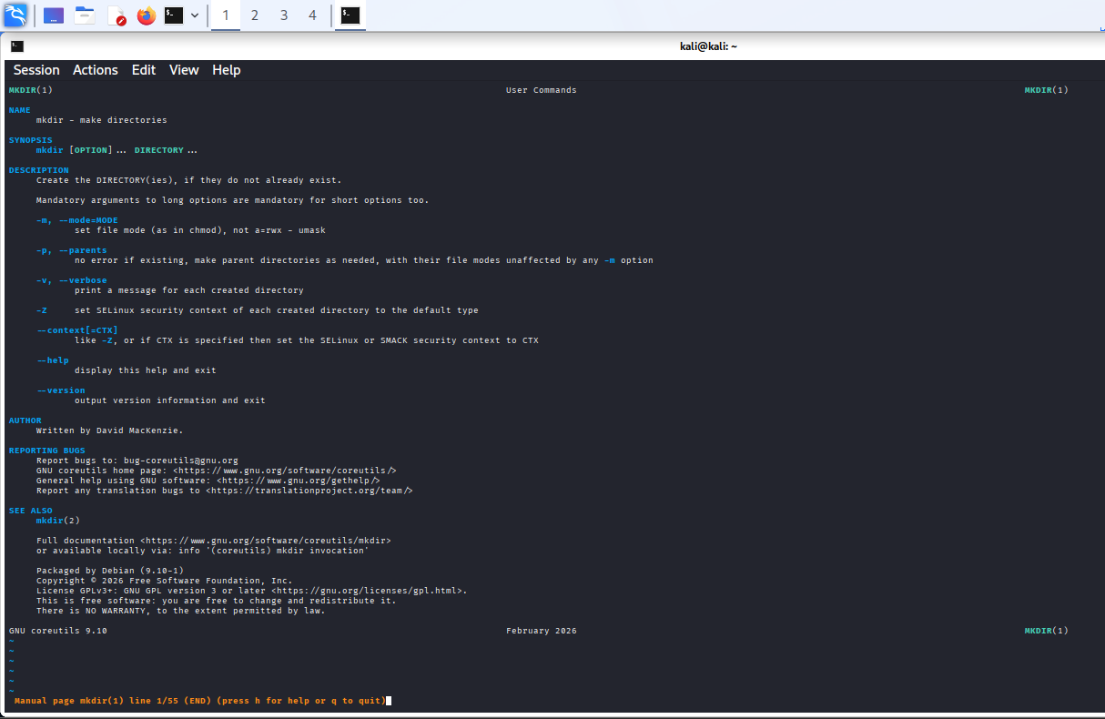
To get manual page for the unknown command | man | Man command | man mklr | 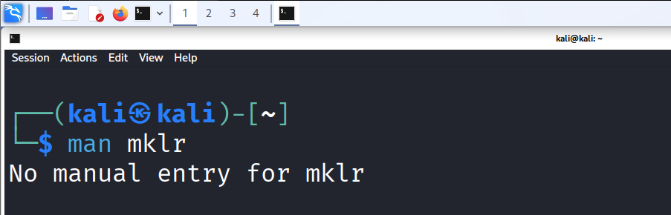
To know the source file binary | which | which command | which ls | 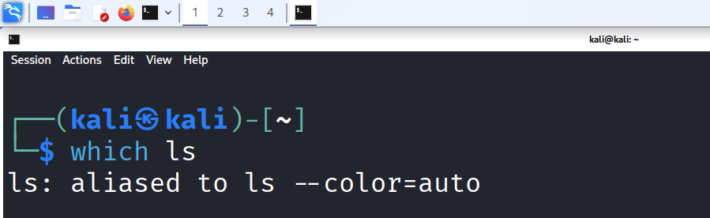
To know the path of the command | whereis | whereis command | whereis bash | 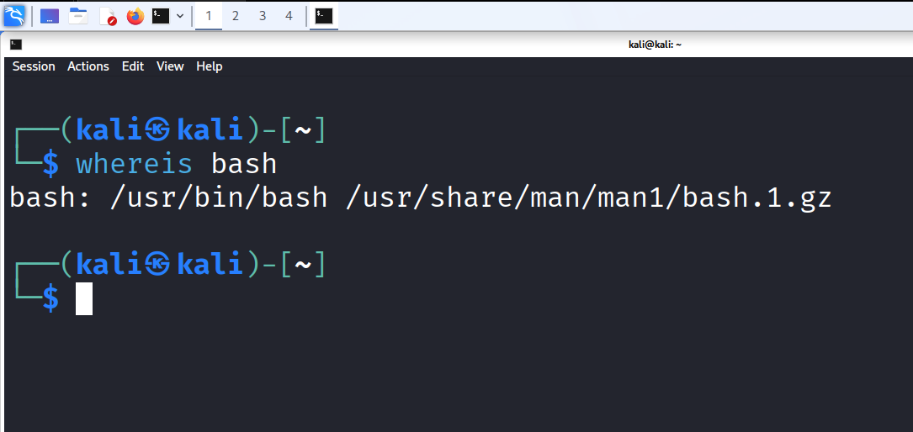
To know the command is external or internal | Type | type command | type ls | 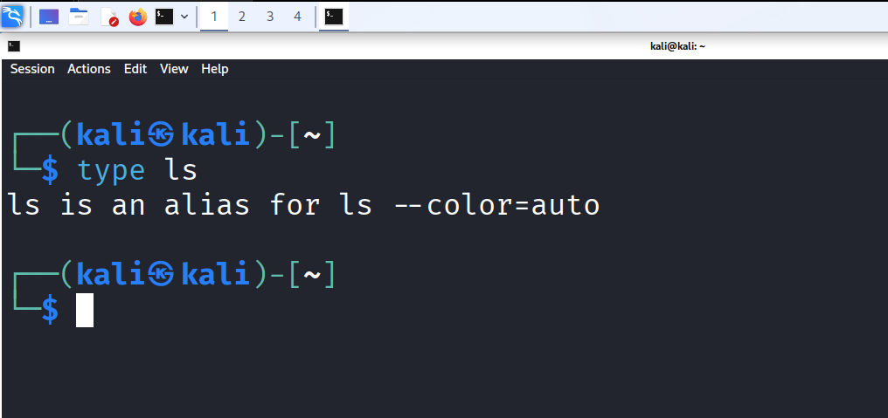
To get help for the internal command | help | run help | run - help cd | 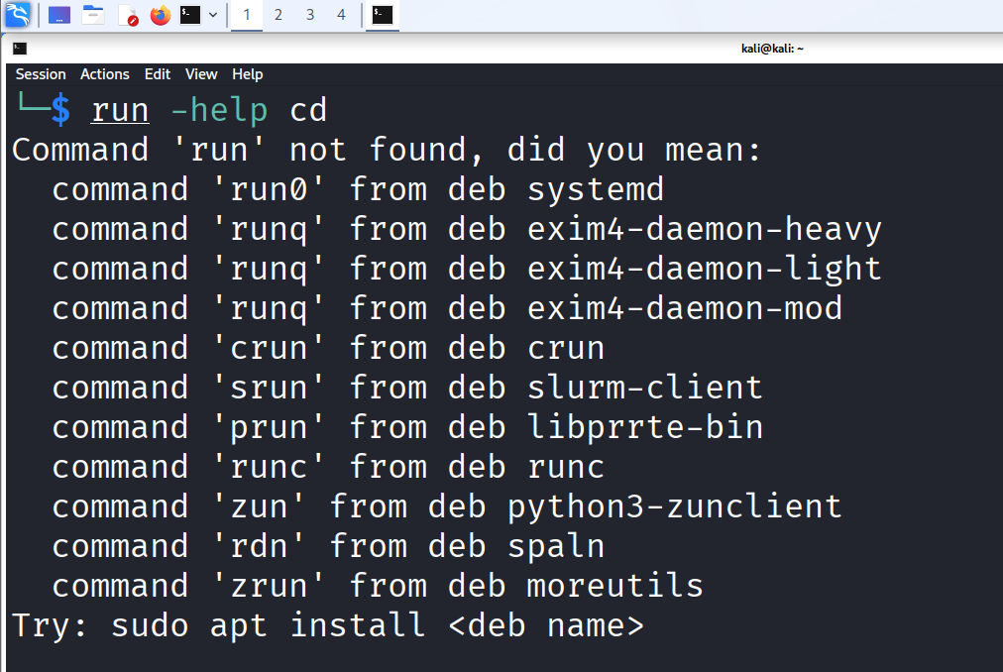
To list out bash commands | compgen | bash compgen -b | bash compgen -b | 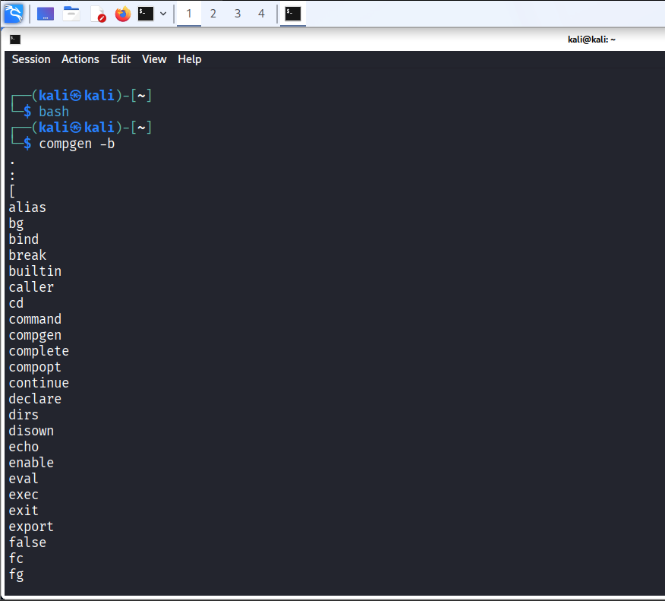
To know the usage of the command | --help | Command --help | cp --help | 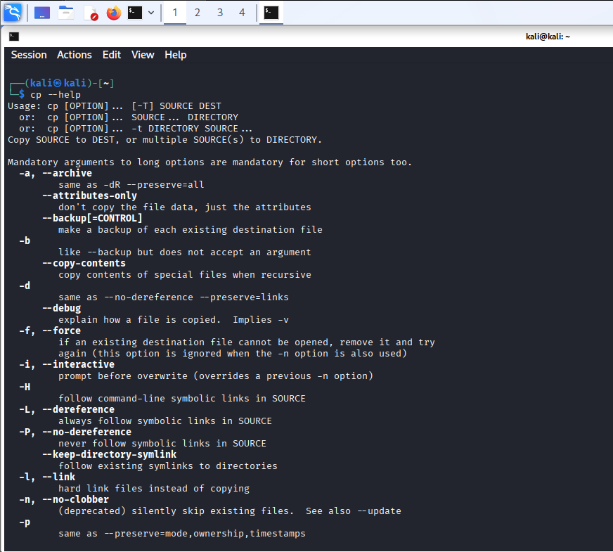

- Basic Commands
Task | Command Name | Syntax | Example | Screenshots
To know today’s date | date | date | date | 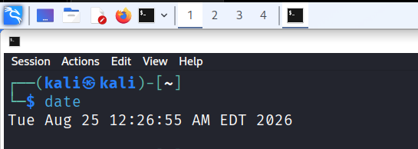
To print calendar | cal | cal | cal | 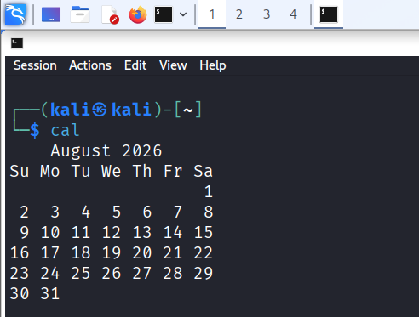
To print kernel version | uname | uname -r | uname -r | 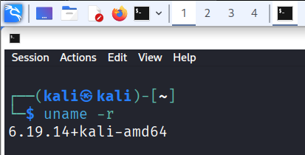
To print default shell | echo | echo $SHELL | echo $SHELL | 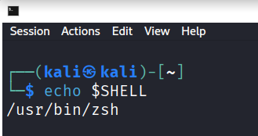
To print currently logged in user | whoami | whoami | whoami | 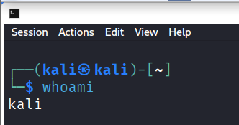
To create shortcut for command | alias | alias name=’command’ | alias list =’ls -i’ | 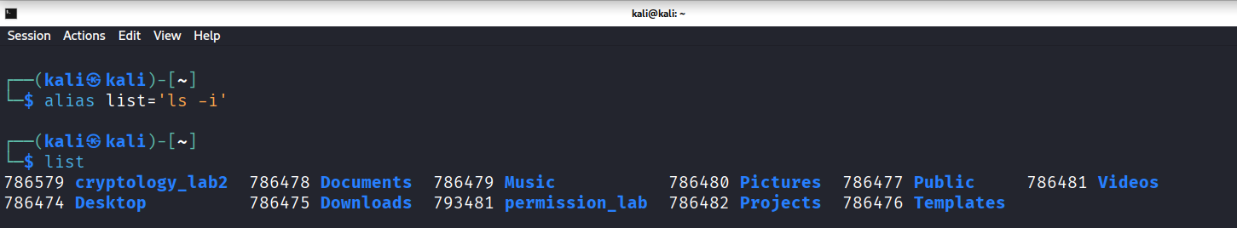
To delete shortcut | unalias | unalias name | unalias list | 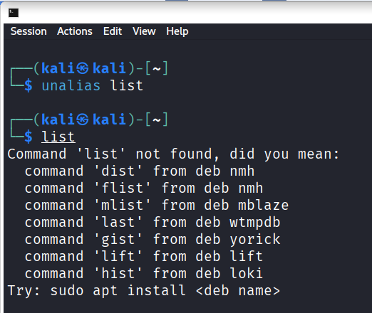
To change the timestamp of the file | touch | touch file | touch a.txt  ls -l a.txt | 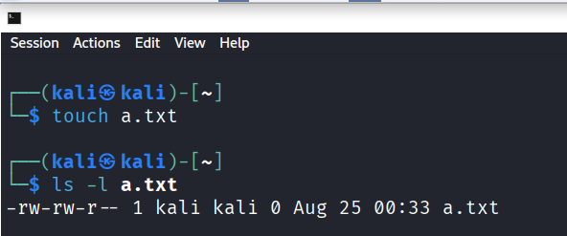
To clear the screen | clear | clear | clear | 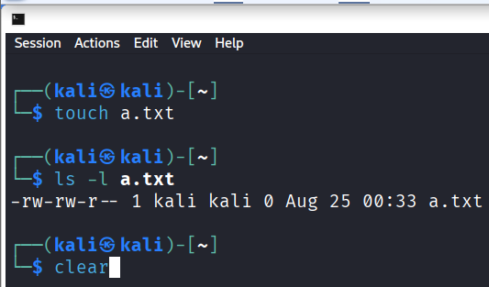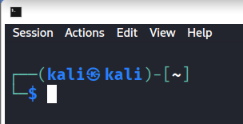
To create empty files | touch | touch filename | touch b.txt | 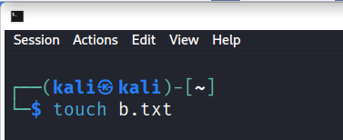
To know disk usage | du | du -sh | du -sh | 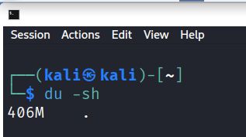
To know free space in the system | df | df -h | df -h | 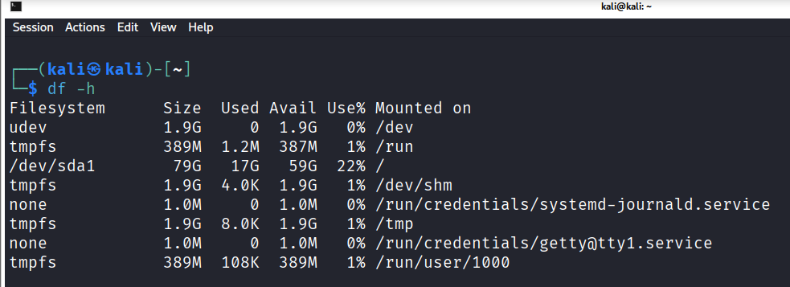
To know about the Linux release | cat | cat/etc/os-release | cat/etc/os-release | 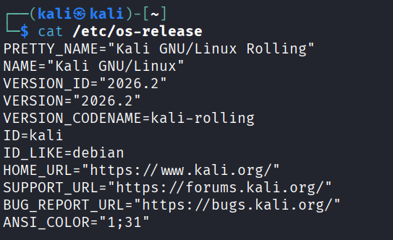
To show login history | last | last | last | 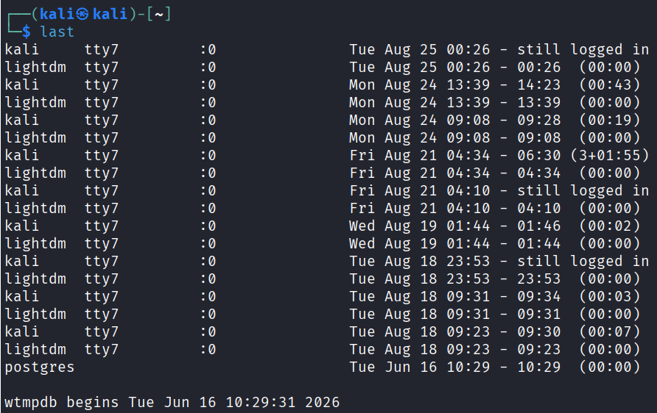
To check the current user privileges | id | id | id
To find about the Linux release | lsb_release | lsb_release -a | lsb_release -a | 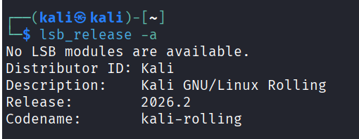
To check system uptime | uptime | uptime | uptime | 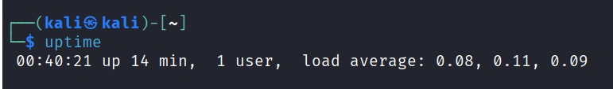
To shutdown | shutdown | Sudo shutdown now | Sudo shutdown now | 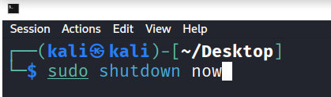
To restart | reboot | Sudo reboot | Sudo reboot | 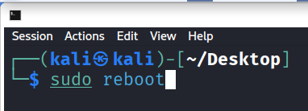

- Navigation
Task | Command | Syntax | Screenshots
To navigate home directory | cd | cd | 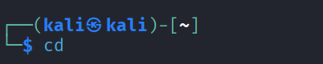
To navigate to the parent directory | cd .. | cd .. | 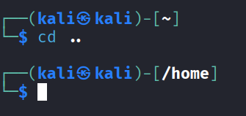
To navigate to the child directory | cd | cd foldername | 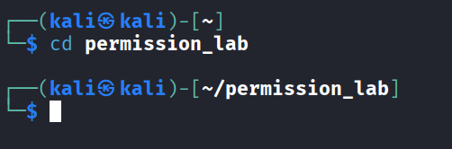
Alternate command to cd | pushd | push directory | 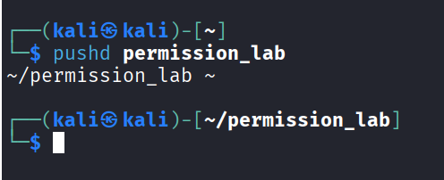
To go back to the previous directory | cd - | cd - | 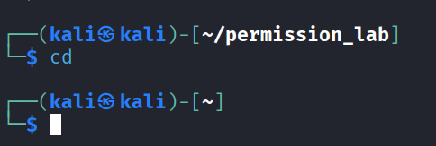
To go to the root directory | cd / | cd / | 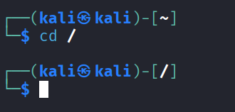

- File System
Task | Syntax | Command | Screenshot
How to identify the file system | df -T | df -T | 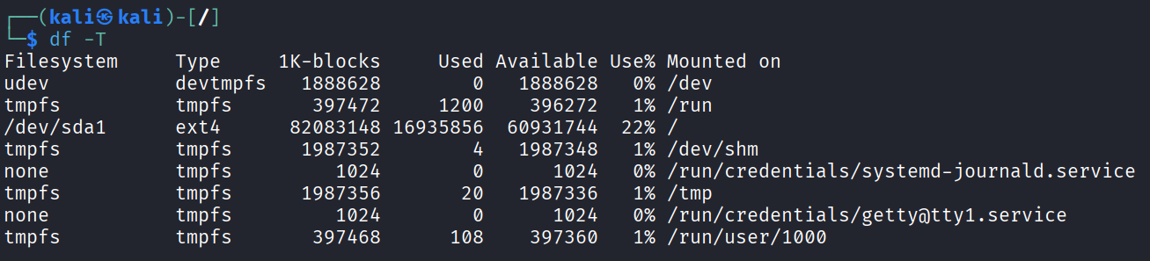

- Globbing
Create a dedicated practice directory containing sample files such as:
index.html, login.html, admin.htm, report.txt, access.log, error.log, user1.txt, user2.log, file123, backup1.html, backup2.txt
Use globbing patterns wherever possible, rather than specifying filenames individually.
- List all files ending in .html.
ls *.html
- List all files other than .html files using extended globbing.
ls !(*.html)
- List filenames containing at least one numeric digit.
ls *[0-9]
- List files whose names begin with user followed by a single digit.
ls user?.*
- List files ending in either .txt or .log using a single extended glob pattern.
ls *.@(txt|log)
- List files that do not end in .txt or .log.
ls !(*.txt|*.log)
- List files beginning with either access or error using extended globbing.
ls @(access|error).log
- List .html files whose filenames contain a numeric digit.
ls *[0-9]*.html
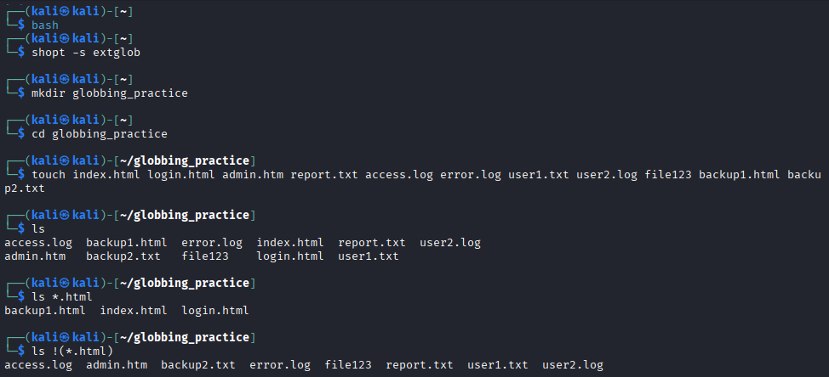
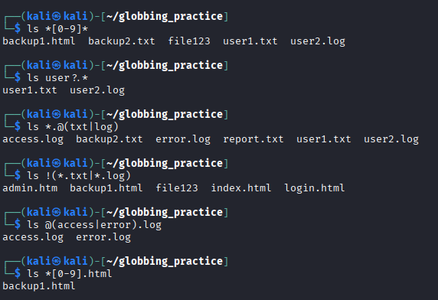
- Extended Globbing
- Assume a directory contains:
access.log, error.log, auth.log, auth.log.1, auth.log.2, system.log, notes.txt
Write an extended glob pattern that selects only access.log, error.log, and auth.log.
ls @(access|error|auth).log
Select all files except notes.txt.
ls !(notes.txt)
Select files named either auth.log.1 or auth.log.2 using pattern matching rather than writing both complete filenames separately.
ls auth.log.@(1|2)

- Given the files:
malware1.log, malware2.log, malwareA.log, malware_report.txt, normal.log
construct a glob pattern that identifies .log files whose names start with malware and contain a numeric character.
ls malware*[0-9]*.log
- Given:
failed_login.log, successful_login.log, login_backup.log, login.txt, firewall.log
use extended globbing to select .log files containing either failed_login or successful_login.
ls @(failed_login|successful_login).log
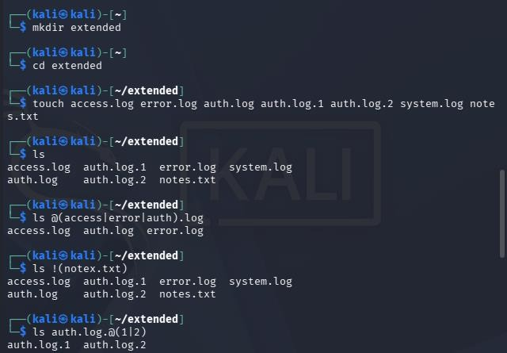
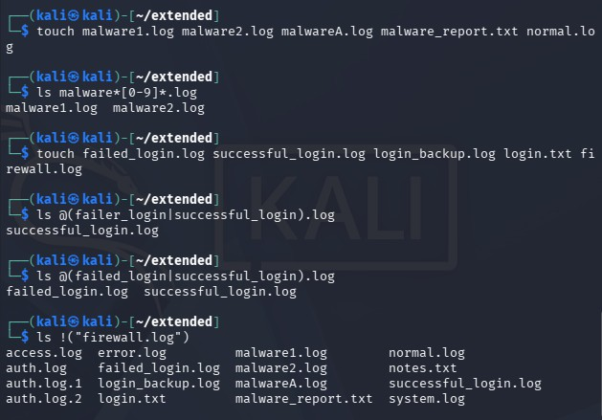
Construct a pattern that lists all .log files except firewall.log.
ls !("firewall.log")

- Filters
a. Display the first 10 entries of login.log.
head -10 login.log

b. Display the first 5 entries of access.log.
head -5 access.log

c. Display the first 15 security events from security.log.
head -15 security.log

d. Display the first 20 events recorded in incident.log.
head -20 incident.log

e. Display only the first entry in login.log.
head -1 login.log

f. Display the first 25 web requests recorded in access.log.
head -25 access.log

g. Display the last 10 entries of login.log.
tail -10 login.log

h. Display the last 5 entries of access.log.
tail -5 access.log

i. Display the 20 most recent security events from security.log.
tail -20 security.log

j. Display the 25 most recent events from incident.log.
tail -25 incident.log

k. Display only the last entry in security.log.
tail -1 security.log

l. Display the last 50 events recorded in incident.log.
tail -50 incident.log

m. Display the contents of login.log starting from line 41 until the end of the file.
tail -n +41 login.log

n. Display the contents of security.log starting from line 101 until the end of the file.
tail -n +101 security.log

o. Find the total number of lines in login.log.
wc -l login.log

p. Find the total number of lines in access.log.
wc -l access.log

q. Find the total number of security events in security.log.
wc -l security.log

r. Determine the total number of events recorded in incident.log.
wc -l incident.log

s. Count the number of words in login.log.
wc -w login.log

t. Count the number of bytes in security.log.
wc -c security.log

u. Display the line, word, and byte counts of access.log.
wc access.log

v. Find the line counts of all four .log files using a single wc command.
wc -l *.log

w. Display the first 20 entries of login.log and, from those entries, display only the last 5.
head -20 login.log | tail -5

x. Display the last 20 entries of login.log and, from those entries, display only the first 5.
tail -20 login.log | head -5

y. Display the first 30 entries of access.log and then display only the last 10 entries from that output.
head -30 access.log | tail -10

z. Display the last 30 entries of access.log and then display only the first 10 entries.
tail -30 access.log | head -10

aa. Display the first 50 events from security.log and then display the last 10 events from those 50.
head -50 security.log | tail -10

bb. Display the last 50 events from security.log and then display the first 10 events from those 50.
tail -50 security.log | head -10

cc. Display entries from line 11 to line 20 of login.log.
head -20 login.log | tail -10

dd. Display entries from line 21 to line 30 of login.log.
head -30 login.log | tail -10

ee. Display entries from line 11 to line 20 of access.log.
head -20 access.log | tail -10

ff. Display entries from line 31 to line 40 of access.log.
head -40 access.log | tail -10

gg. Display security events from line 21 to line 30 of security.log.
head -30 security.log | tail -10

hh. Display security events from line 51 to line 60 of security.log.
head -60 security.log | tail -10

ii. Display incident events from line 101 to line 110 of incident.log.
head -110 incident.log | tail -10

jj. Display incident events from line 201 to line 220 of incident.log.
head -220 incident.log | tail -20

kk. Display incident events from line 491 to line 500.
head -500 incident.log | tail -10

ll. Take the first 20 entries of login.log and count how many lines are displayed.
head -20 login.log | wc -l

mm. Take the last 15 entries of access.log and count how many lines are displayed.
tail -15 access.log | wc -l

nn. Take the first 50 entries of security.log and count the number of words in those entries.
head -50 security.log | wc -w

oo. Take the last 25 entries of security.log and count the number of lines.
tail -25 security.log | wc -l

pp. Extract lines 21–30 from login.log and count the number of extracted lines.
head -30 login.log | tail -10 | wc -l

qq. Extract lines 51–60 from access.log and count the number of extracted lines.
head -60 access.log | tail -10 | wc -l

rr. Extract events 101–150 from incident.log and count how many events are displayed.
head -150 incident.log | tail -50 | wc -l

ss. Display the first 100 events from incident.log, take the last 20 events from that output, and count the number of lines.
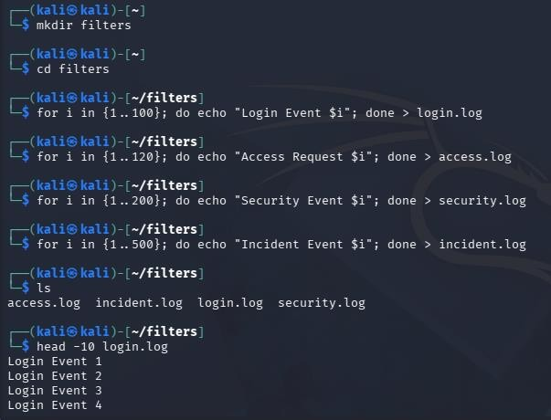
head -100 incident.log | tail -20 | wc -l

